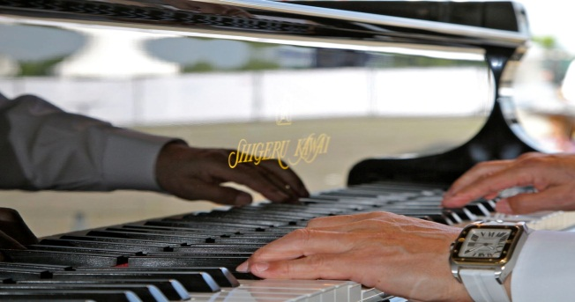

Curriculum Vitae

Yasuto Ohara

Recognized by his original style and well-crafted technique, Japanese Jazz Pianist Yasuto Ohara is one of the finest mainstream players in the world.

His first contact with the piano was at the age of three. After that, he was classically trained until eighteen years old. At that time, mainly inspired by the wonderful music of John Coltrane, he decided to start a career as a Jazz Pianist. With his band, the Yasuto Ohara Super Jazz Trio, he soon started to perform across the globe, including shows in the US (New York), China, Thailand, and New Zealand. In no time his career as a worldwide acclaimed Jazz pianist gained momentum.
Until this day, his performance style can be described as energetic, swinging, and lyrical. Recognized by many Jazz lovers around the world, his unique style has led to various festival invitations. These include the Montreux Jazz Festival in 1997 and 2004, the Paris Lionel Hampton Jazz Club, the Fairmont Hotel of Monte Carlo in 2007, as well as the 2010 Japan Day in Düsseldorf. In 2011, as a commemoration of the 150th anniversary of German-Japan Friendship, the Yasuto Ohara Super Jazz Trio Concert was held at the Tonhalle in Düsseldorfs to great success. He was again invited for a solo engagement during Japan Day 2012 and 2015,as well as Program Summer 2014 in Slovenia.
His performance was also a great success at Dalian People’s Cultural Hall in China in 2016.
Ohara’s usual performance venue is his own Jazz Club "Eighty-One" in Chiba Japan. In addition to regular performances there, he also directs the annual music event 'BAY SIDE JAZZ CHIBA'.

His warm and generous heart is displayed during his regular performances at schools for disabled children.
He was consequently awarded the Chiba Prefectural Award of Honor in Culture in 2007.

Yasuto Ohara held a concert at ‘Maison de la Culture du Japon a Paris’ on November 7th at Japonism 2018.

